N+ Network Security
Software and Hardware Tools
1. Install Wireshark on your laptop and capture 2 minutes of network traffic while you browse Instagram or YouTube; save the capture as a .pcap file and note the top 3 protocols you see.
= Steps
  - Install Wireshark.
  - Start capturing on your Wi-Fi or Ethernet interface.
  - Browse Instagram or YouTube for 2 minutes.
  - Stop the capture.
  - Save it as network_capture.pcap.
Top 3 Protocols (Example)
Protocol | Purpose
TLS | Secure HTTPS communication
TCP | Reliable data transfer
DNS | Converts website names to IP addresses

2. Use the 'ping' command in Command Prompt or Terminal to test connectivity to www.spotify.com and www.zomato.com; record the response times and identify which site responds faster.
=

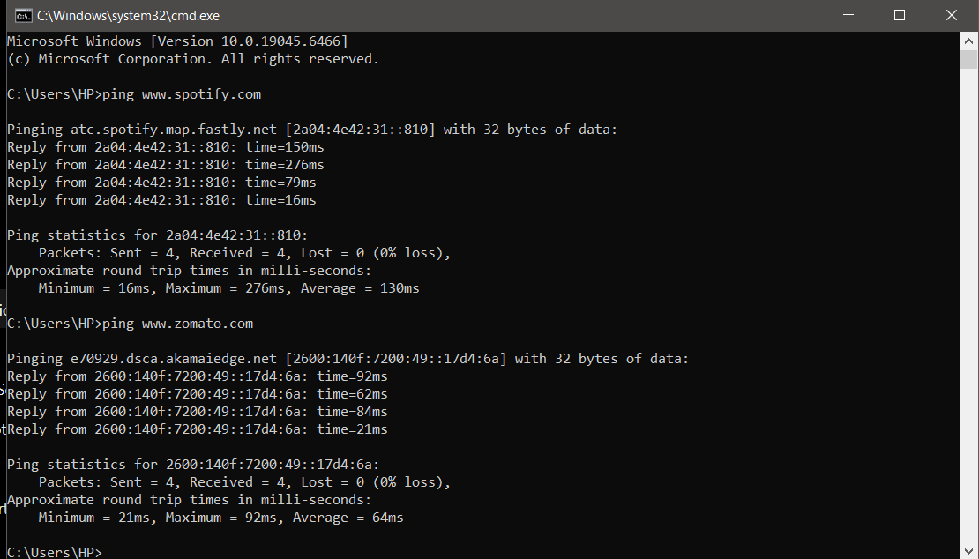
3. Open Task Manager (Windows) or Activity Monitor (Mac) and list all running processes related to Chrome, WhatsApp Desktop, or any browser-based app you use; note the process name and memory usage for each.
= 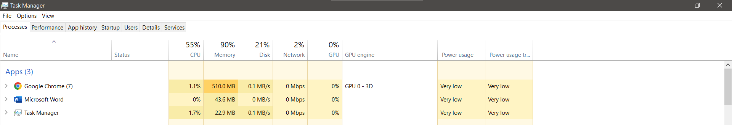
4. Download and run the free version of 'Angry IP Scanner' or 'Advanced IP Scanner' to scan your local WiFi network; list the IP and device name of at least 2 devices connected to your network.<br><br><em><strong>Hint:</strong> Make sure your firewall allows scanning, and only scan your own home/college network.</em>
= Tool
• Advanced IP Scanner or Angry IP Scanner
Example Output
IP Address | Device Name
192.168.1.1 | TP-Link Router
192.168.1.100 | Hensie-Laptop

5. Use ChatGPT or Bing AI to suggest 3 hardware tools (like cable tester, crimping tool, or multimeter) used in network troubleshooting; for each, write one line describing when you would use it.
=
Hardware Tool | When You Would Use It
Cable Tester | To check whether an Ethernet cable is wired correctly and detect faults like broken or crossed wires.
RJ45 Crimping Tool | To attach or replace RJ45 connectors when making or repairing Ethernet cables.
Digital Multimeter | To measure voltage, continuity, and electrical faults in network devices and power supplies.

